[Title Here, up to 12 Words, on One to Two Lines]

Adda Ashcraft

Ohio University, Russ College

ISE 4100

Abstract

This essay will include the comparison of an Ultrasonic, Capacitive, and Photoelectric sensors. This comparison will be done with the sole intention to determine the most accurate technology for counting people that pass down a hallway. The differences between these sensors was found through research, not experimentation. This sensor will be used in conjunction with an Arduino Nano and a temperature/humidity sensor.

[Title Here, up to 12 Words, on One to Two Lines]

# Ideal Functionality of Sensor

The sensor chosen must be able to send a signal that can detect when a person is present in the signal line of path. Activate for measurement to be recorded accurately in terms of distance, speed, and time used for object to enter and leave the signals designated area. The objects that the sensor will be identifying will be human beings. Therefore the sensor must interact well with typical clothing like fabrics and metals.

## Sensor Candidates

Capacitive Sensor: As a ferrous or non-ferrous object enters the sensing zone, capacitance increases; circuit natural frequency shifts towards the oscillation frequency, causing amplitude gain. Because of the capacitive sensors sensitivity to metals, the sensor must be secluded from any non-target metals. Exposure to any metal other than the target metal can cause for false-triggering. (Kinney, 2001)

Photoelectric Sensors: Transmit a beam of visible or infrared light to detecting receiver. There are three types of photoelectric sensor configurations: through-beam, retro-reflective, and diffused-beams. (Kinney, 2001) A beam is constantly emitted and when the beam is broken by the target then the output is initiated. An illustration of these three types is presented in FIGURE 1 on page 4 on this report.

The through-beam photo-electric sensor is configured so that the emitter sends a constant beam to its receiver that is opposite to the emitter. When this beam is broken by a target then the output is registered. This option was eliminated because the through-beam is costly and difficult to install and set-up.

The diffusing photoelectric sensors functions by using the target as a reflector. The sensor set up is similar to the retro-reflective sensor in that the emitter and receiver are facing the same direction in the same housing. However, when a target interrupts the constant beam emitted then the receiver initiates the output because light is being reflected from the target into the receiver. One issue with this sensor is that any non-reflective targets (for example a matte black) would decrease the sensing range significantly because a majority of the light emitted would be absorbed. A study was done on Infrared Sensors that were configured in this fashion and concluded that Infrared sensors can perform better that Ultrasonic sensors when a sheet of paper is used as the target. (Adarsh, 2016) This is because of the reflective nature of the paper with respect to light.

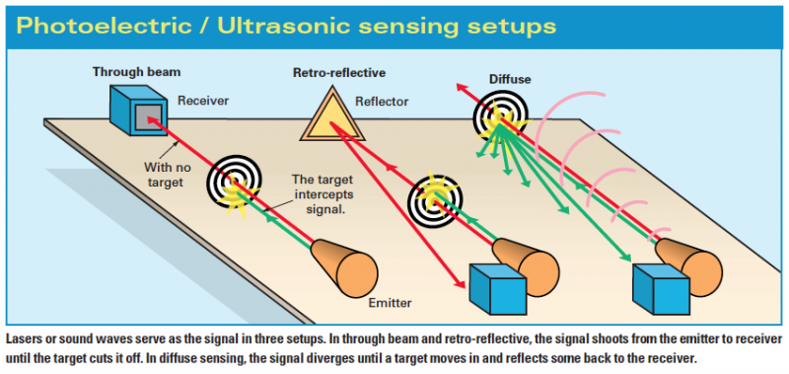

Figure 1 illustrates the three Photoelectric / Ultrasonic sensing setups.

The final sensor studied was the ultrasonic sensor. The ultrasonic sensor emits an ultrasonic ping and the waits for the echo to be received by the sensor. The echo is received and the distance is calculated based off of the change in time from the moment the ping is emitted to when it is received in the receiver with respects to the speed of sound in air (343 meters per second). This sensor is ideal for detection of sound absorbent and deflective materials such as cotton, foam, cloth, and rubber. (Kinney, 2001) Another surprising twist was that the ultrasonic sensor reacted well with sponge-like material in comparison to the paper as a reflective-target. (Adarsh, 2016) It seems that the ultrasonic sensor reacts better if the noise from the signal being reflected is absorbed like in a sponge. Whereas the paper enables for a majority of the ping to be sent through the paper so that hardly any echo from the ping is received. Refer to Figure 1 to notice that the longest range is taken advantage of with a diffuse set-up for an ultrasonic sensor. Therefore a stronger signal can be used to detect a target. Also with the array of signals then the angle and distance traveled over a given amount of time can be calculated using basic trigonometry. These calculations will then be used to calculate the targets speed and path-direction.

### Conclusion

Proper analysis of this research has led to the belief that the ultrasonic sensor will be the most ideal technology to be used in this project. This conclusion is based on financial, technological set up and specialties in sensor usage. The ultrasonic sensor has proven to be the most cost effective in terms of time to setup the sensor and monetary value. Also this sensor will be ideally receptive to the assumed clothing options that our targets will wear. My next steps in this project will be to determine the coding needed in order to filter out any garbage data from faulty readings. Faulty data could be a result of humidity, temperature, path patterns of targets, and non-human target readings.

# References

Adarsh, S. K. (2016). *Performance comparison of Infrared and Ultrasonic sensors for obstacles of different materials in cehicle/ robot navigation applications.* IOP Conference Series: Materials Science and Engineering. Retrieved from https://doi.org/10.1088/1757-899X/149/1/012141

Kinney, T. A. (2001, September 1). Proximity Sensors Compared: Inductive, Capacitive, Photoelectric, and Ultrasonic. Retrieved from http://www.machinedesign.com/sensors/proximity-sensors-compared-inductive-capacitive-photoelectric-and-ultrasonic